TURKMEN CARPET MAKING
Today I learned about Turkmenistan and the tradition of Turkmen carpet making. Turkmens use sheep’s wool to make textile patterns, which they then use to make colorful and complex carpets. Carpet making is a very important part of Turkmen culture and identity.

FROM:

TURKMEN CARPET MAKING
Today I learned about Turkmenistan and the tradition of Turkmen carpet making. Turkmens use sheep’s wool to make textile patterns, which they then use to make colorful and complex carpets. Carpet making is a very important part of Turkmen culture and identity.

FROM:

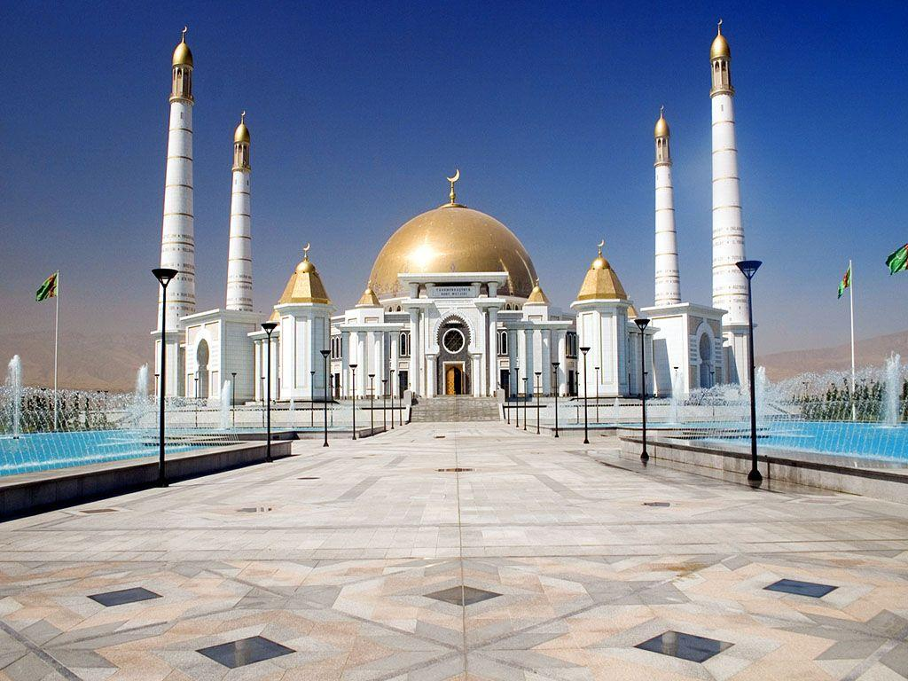
Turkmenistan

Turkmenistam
Turkmenistan

