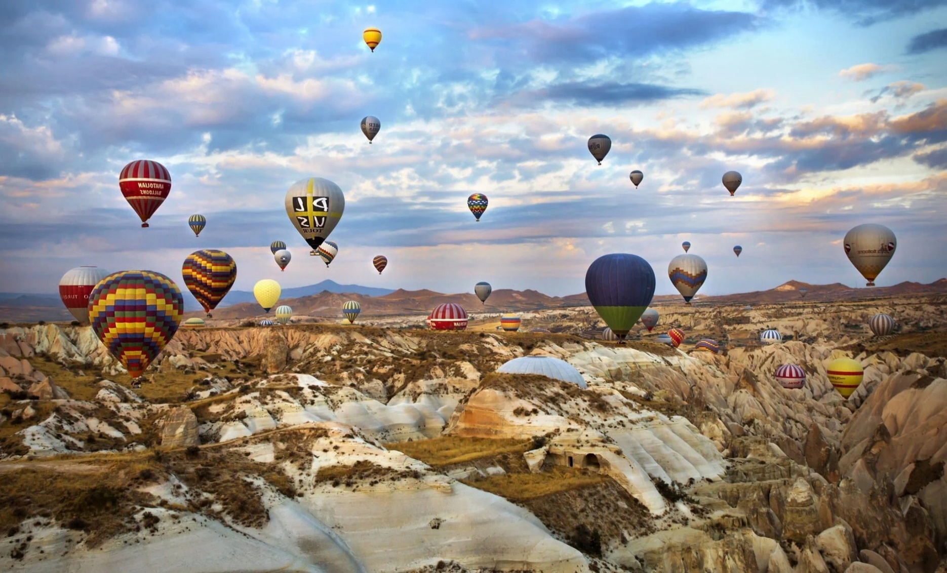

…TÜrkiye!

…TÜrkiye!

Greetings from…

Greetings from…

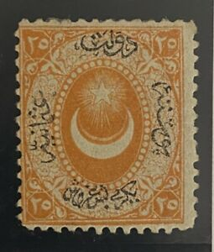

**Today I learned about a country called Türkiye. We visited the Grand Bazaar in Istanbul, where they sell spices, lanterns, clothing, and much more! We also learned about a region called Cappadocia, that has underground cities and rock formations called “fairy chimneys.” This area is famous for hot-air balloon rides, so we decorated our own hot-air balloons!**

**Hot-air balloon rides in  
Cappadocia, Türkiye!**

**FROM:**



**Today I learned about a country called Türkiye. We visited the Grand Bazaar in Istanbul, where they sell spices, lanterns, clothing, and much more! We also learned about a region called Cappadocia, that has underground cities and rock formations called “fairy chimneys.” This area is famous for hot-air balloon rides, so we decorated our own hot-air balloons!**

**Hot-air balloon rides in  
Cappadocia, Türkiye!**

**FROM:**