**Azerbaijan**

~~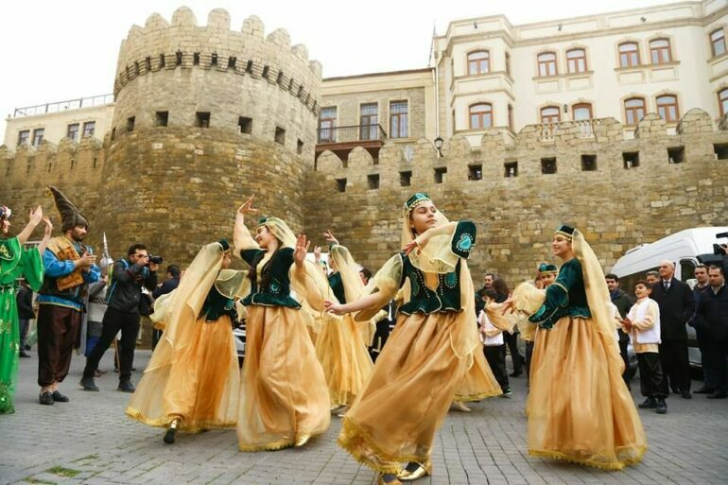~~

**Azerbaijan**

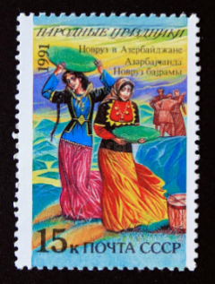Novruz

**Today I learned about Azerbaijan. It is a country in southwestern Asia in the Caucasus Mountain region. In the spring in Azerbaijan, they celebrate a holiday called Novruz. They are celebrating the Persian new year and the coming of Spring. One of the symbols of Novruz is the egg because it symbolizes rebirth. Today I got to make my own Novruz egg!**

**FROM:**

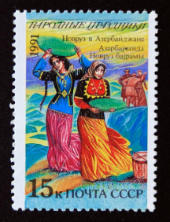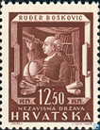Novruz

**Today I learned about Azerbaijan. It is a country in southwestern Asia in the Caucasus Mountain region. In the spring in Azerbaijan, they celebrate a holiday called Novruz. They are celebrating the Persian new year and the coming of Spring. One of the symbols of Novruz is the egg because it symbolizes rebirth. Today I got to make my own Novruz egg!**

**FROM:**