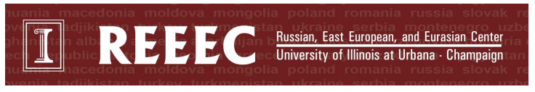

Pre-Kindergarten Curriculum
Novruz (Azerbaijan)
10 minutes prep, 30 minutes of class time
This lesson is designed to introduce students to Azerbaijan. Students will learn about Novruz, a holiday that celebrates the Persian new year and the coming of spring. Students will create their own Novruz egg, one of the symbols of the holiday.

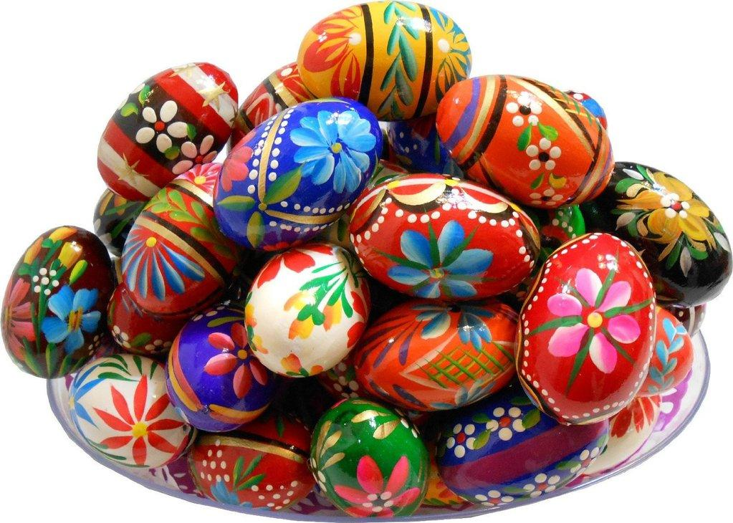
Required Materials:
- Colored paper
- Patterned templates with zigzag lines, polka dots, etc.
- Scissors
- Markers
- Glue
Preparation:
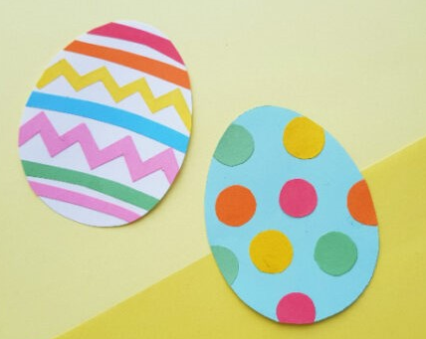
Cut out an egg shape from the colored paper. Download and print templates that students can cut out and use to decorate their egg with. Place the egg, the templates, markers, glue, and scissors at each student’s desk.

Lesson Plan:
- Begin by asking the children what country we live in, and then help them locate that country on a map or globe. Then show them where Azerbaijan is on a map/globe. (2 mins)
- Use the PowerPoint or printed images to take the children on a tour of Azerbaijan (see power point for more detailed notes on images) (5 mins)
  - First highlight the landscape of Azerbaijan, which includes the Caucasus Mountains and the Caspian Sea coastline.
  - Discuss Novruz and how Azerbaijanis celebrate the Persian new year to celebrate the coming of Spring.
- Discuss how Novruz has many symbols including the egg The activity (10 mins):
  - Explain to the students that the activity is of a paper egg.
  - Have them cut out what décor they want to use on their egg. Glue the lines or polka dots to the egg.
  - Let them decorate the egg with markers.

