Pre-Kindergarten Curriculum
Komi Sun Elk (Komi Republic)
5 minutes prep, 30 minutes of class time
This lesson is designed to introduce students to the Komi Republic. Students will learn about the Komi people and the practice of Komi people to hunt elk. They will hear a Komi folktale about the Sun Elk. They will then make their own Sun Elk.

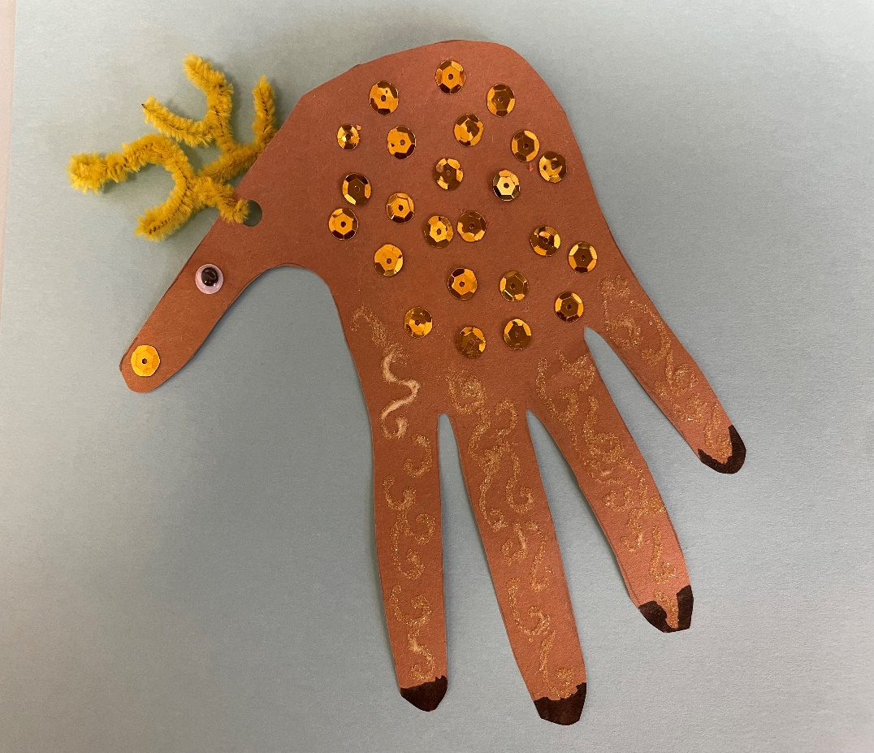
Required Materials:
- Brown construction paper
- Googly eyes
- Pipe cleaner
- Markers
- Scissors
- Glue
- Hole puncher
- Glitter

Preparation: Place a brown piece of construction paper at each student’s desk. Place googly eyes and one pipe cleaner at each student’s desk. Put markers, glue, and scissors out for students to share.

Lesson Plan:
- Begin by asking the children what country we live in, and then help them locate that country on a map or globe. Then show them where the Komi Republic is on a map/globe. (2 mins)
- Use the PowerPoint or printed images to take the children on a tour of the Komi Republic. (see power point for more detailed notes on images) (5 mins)
  - First highlight the landscape of the Komi Republic.
  - Then introduce the Komi people and elk hunting.
  - Tell the folktale of the Sun Elk.
- The activity (10 mins):
  - Explain to the students that the activity is of the Sun Elk from the Komi folktale.
  - Help the students to trace their hand into the brown construction paper. Then cut out the outline.
  - Turn the hand upside down. Glue the googly eyes to the thumb on the hand outline.
  - Use the hole puncher to cut a hold out in the head of the elk. Use a small piece of pipe cleaner to pull through the hole and twist it together to make the antlers.
  - Decorate the elk with markers, glitter etc.

