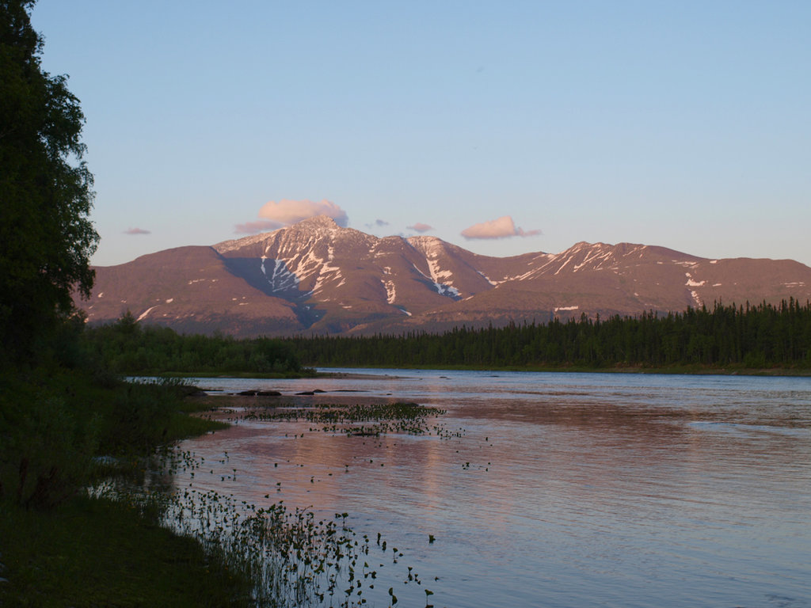

**Komi Republic**

**Komi Republic**

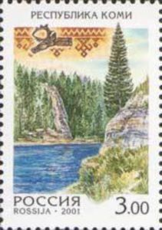The Komi Sun Elk

**Today I learned about the Komi Republic in Russia. I learned about the Komi people and their tradition of elk hunting! I heard a Komi folktale about the Sun Elk, who was a goddess that brought luck to elk hunters! I even got to make my own Sun Elk!**

**FROM:**



The Komi Sun Elk

**Today I learned about the Komi Republic in Russia. I learned about the Komi people and their tradition of elk hunting! I heard a Komi folktale about the Sun Elk, who was a goddess that brought luck to hunter! I even got to make my own Sun Elk!**

**FROM:**