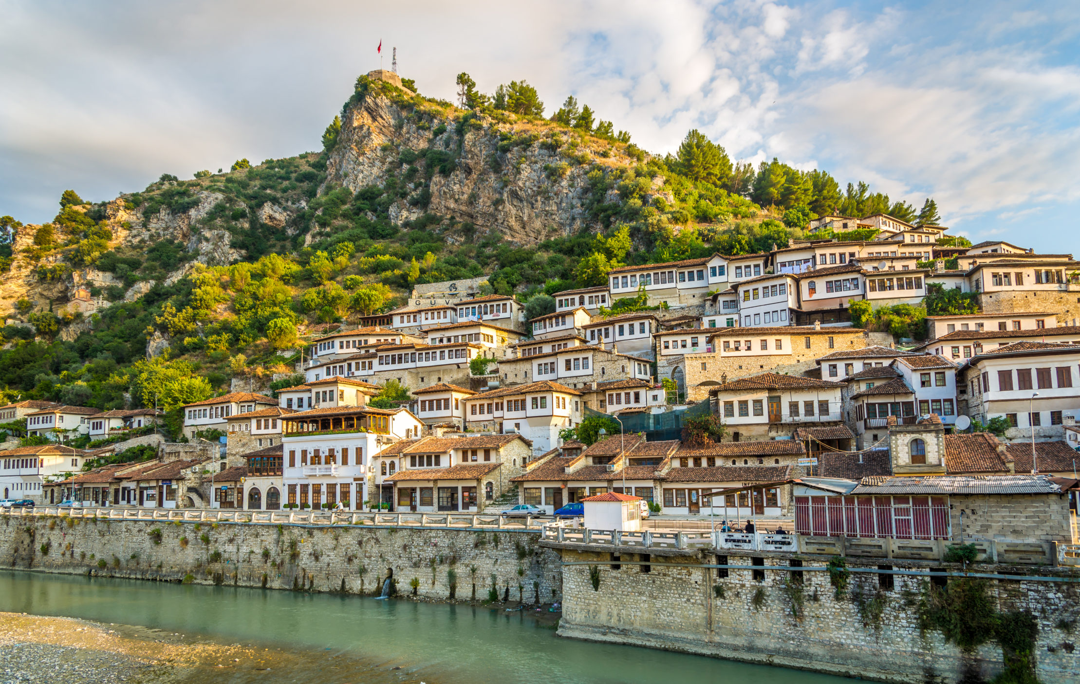

Albania

**Albania**

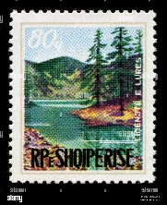Albanian Sheep

**Today I learned about Albania. I learned about Albanian Independence Day, which is on November 28th. I also learned about traditional Albanian felt caps and how they are made from wool from Albanian sheep. I got to make my own Albanian sheep!**

**FROM:**

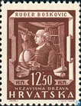 Albanian Sheep

**Today I learned about Albania. I learned about Albanian Independence Day, which is on November 28th. I also learned about traditional Albanian felt caps and how they are made from wool from Albanian sheep. I got to make my own Albanian sheep!**

**FROM:**