Pre-Kindergarten Curriculum
Albanian Sheep (Albania)
10 minutes prep, 30 minutes of class time
This lesson is designed to introduce students to Albania. Students will learn about Albanian sheep and Albanian felt caps. Students will create their own Albanian sheep using paper plates and cotton balls.

Required Materials:
- Paper plates
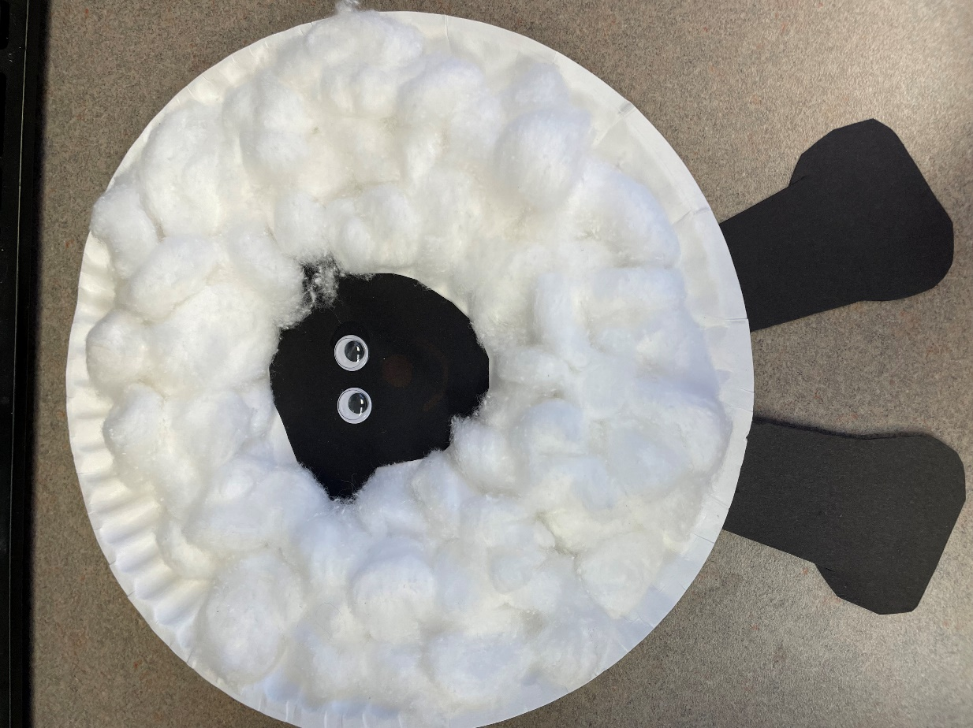
- Cotton balls
- Black construction paper
- Googly eyes
- Scissors
- Glue

Preparation:
Cut out enough sheep heads and legs from black construction paper. Place one sheep head, two legs, a paper plate, and enough cotton balls at each student’s desk.

Lesson Plan:
- Begin by asking the children what country we live in, and then help them locate that country on a map or globe. Then show them where Albania is on a map/globe. (2 mins)
- Use the PowerPoint or printed images to take the children on a tour of Albania (see power point for more detailed notes on images) (5 mins)
  - First highlight the landscape of Albania, which includes lots of mountains and coastline.
  - Discuss the Albanian Independence Day on November 28th. This day marks the day in history when Albania gained independence from the Ottoman Empire.
  - Introduce the tradition of the Albanian felt cap and how it is made from Albanian sheep’s wool.
- The activity (10 mins):
  - Explain to the students that the activity is of a sheep.
  - Have them tear up and glue cotton balls to a paper plate.
  - Then have them glue googly eyes to the black construction paper, which is the sheep’s face.
  - Then have them glue the face on top of the cotton balls and attach the black construction paper legs to the back of the paper plate.

