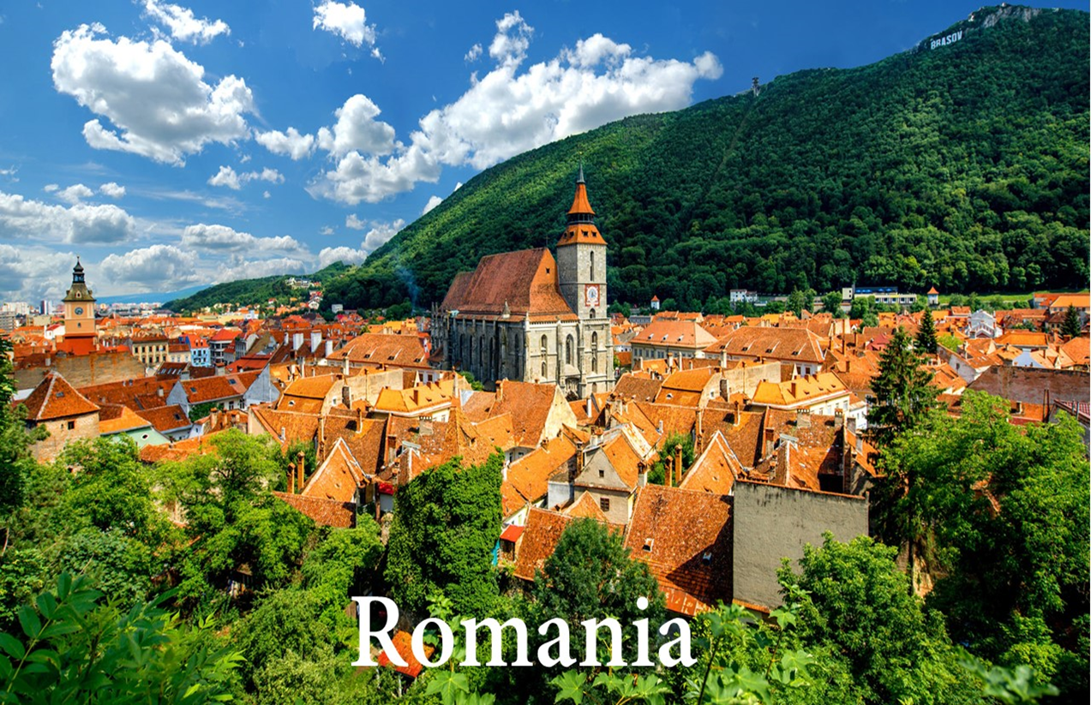

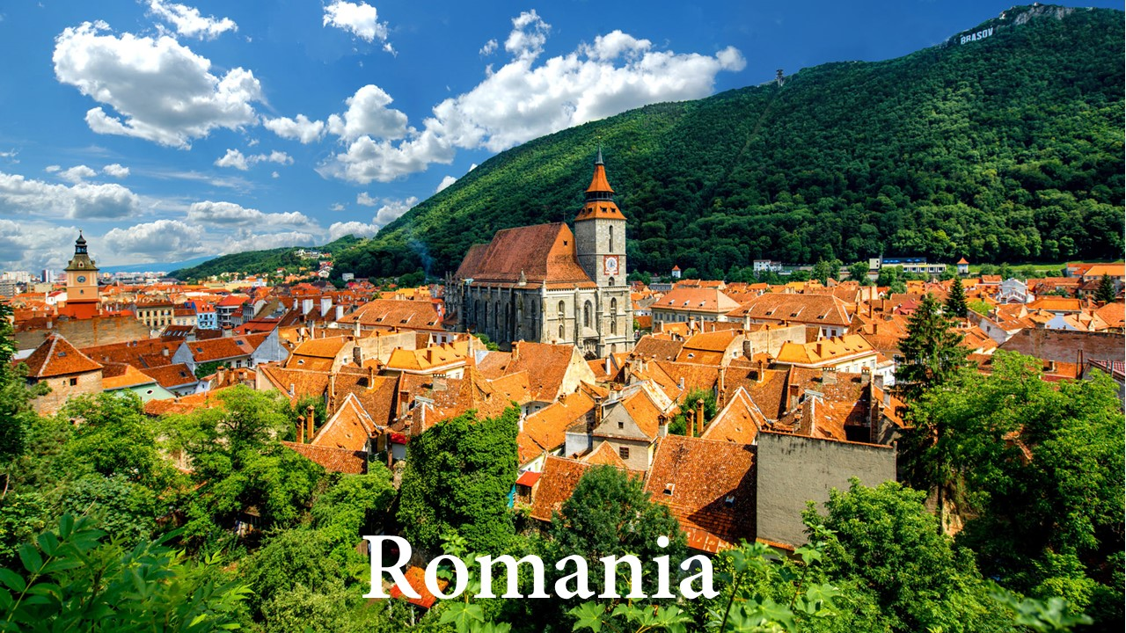

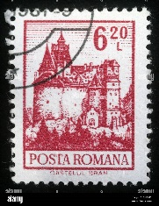Romanian Bats

**Today I learned about Romania. Romania is a country in Southeastern Europe that has lots of mountains and medieval towns! Romania is home of many spooky folktales including stories about vampires. Today we learned about some folktales where vampires turn into bats. We also got to make our own bats!**

**FROM:**

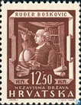 Romanian Bats

**Today I learned about Romania. Romania is a country in Southeastern Europe that has lots of mountains and medieval towns! Romania is home of many spooky folktales including stories about vampires. Today we learned about some folktales where vampires turn into bats. We also got to make our own bats!**

**FROM:**