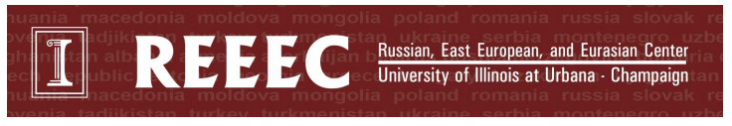

Pre-Kindergarten Curriculum
Romanian Bats (Romania)
10 minutes prep, 30 minutes of class time
This lesson is designed to introduce students to Romania. Students will learn about Romanian folklore and stories about vampires that live in Romania. Students will create their own bats using coffee filters and construction paper.

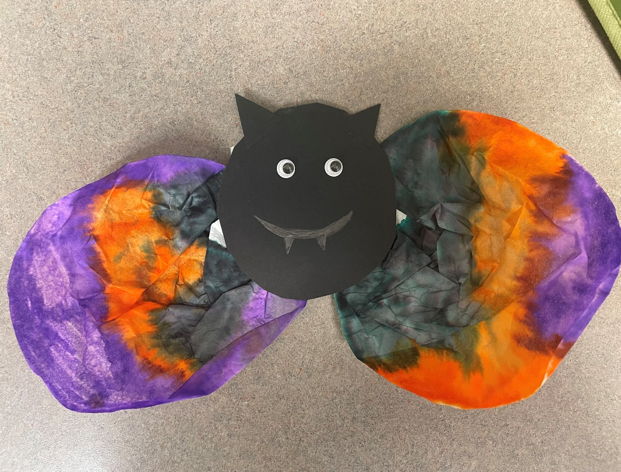
Required Materials:
- Markers
- Coffee filters
- Black construction paper
- Googly eyes
- Tape or glue
- Spray bottle

Preparation: Cut out medium sized black circles to be the body of the bat and small black triangles to be the ears of the bat. Place two googly eyes, one black circle, two black ears, and two coffee filters at each student’s seat.

Lesson Plan:
- Begin by asking the children what country we live in, and then help them locate that country on a map or globe. Then show them where Romania is on a map/globe. (2 mins)
- Use the PowerPoint or printed images to take the children on a tour of Romania (see power point for more detailed notes on images) (5 mins)
  - First highlight the medieval towns, castles, and mountains of Romania.
  - Discuss how Romanian folklore tells stories of many magical creatures that live in the Transylvanian Mountains. You can mention how the movie Hotel Transylvania is inspired by the book and folktale Dracula. Mention how the main character Dracula can turn into a bat and how many bats live in Romania.
- The activity (10 mins):
  - Explain to the students that the activity is of a bat.
  - Have them color the coffee filters with markers and spray the coffee filters with water. Set them aside and let them dry.
  - Help the kids glue on the eyes and ears to the bat’s body while the coffee filters dry and encourage them to draw on the bat’s face.
  - Attach the coffee filters to the back of the bat’s body to be the wings of the bat.

