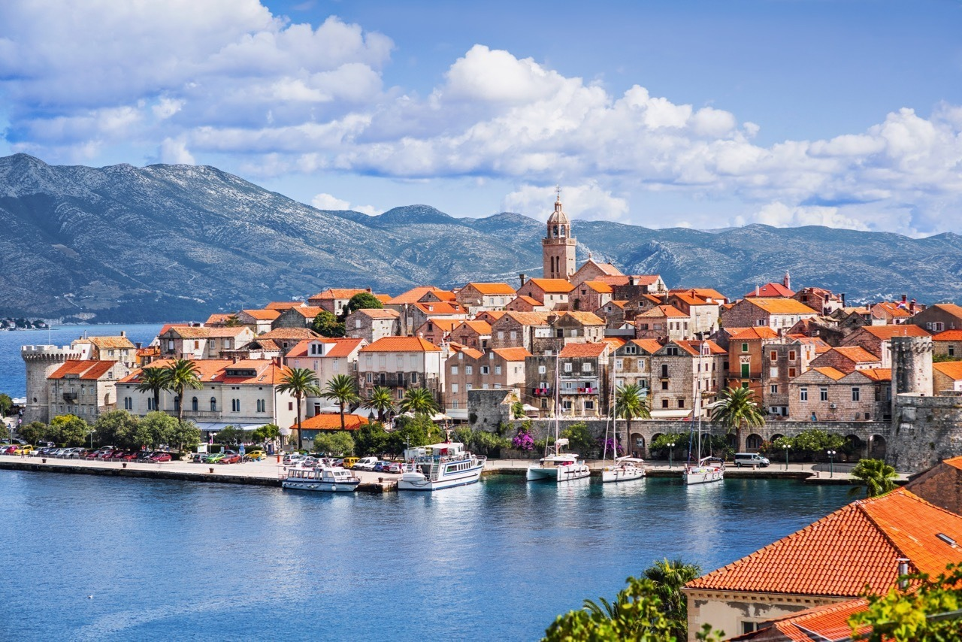

**CROATIA**

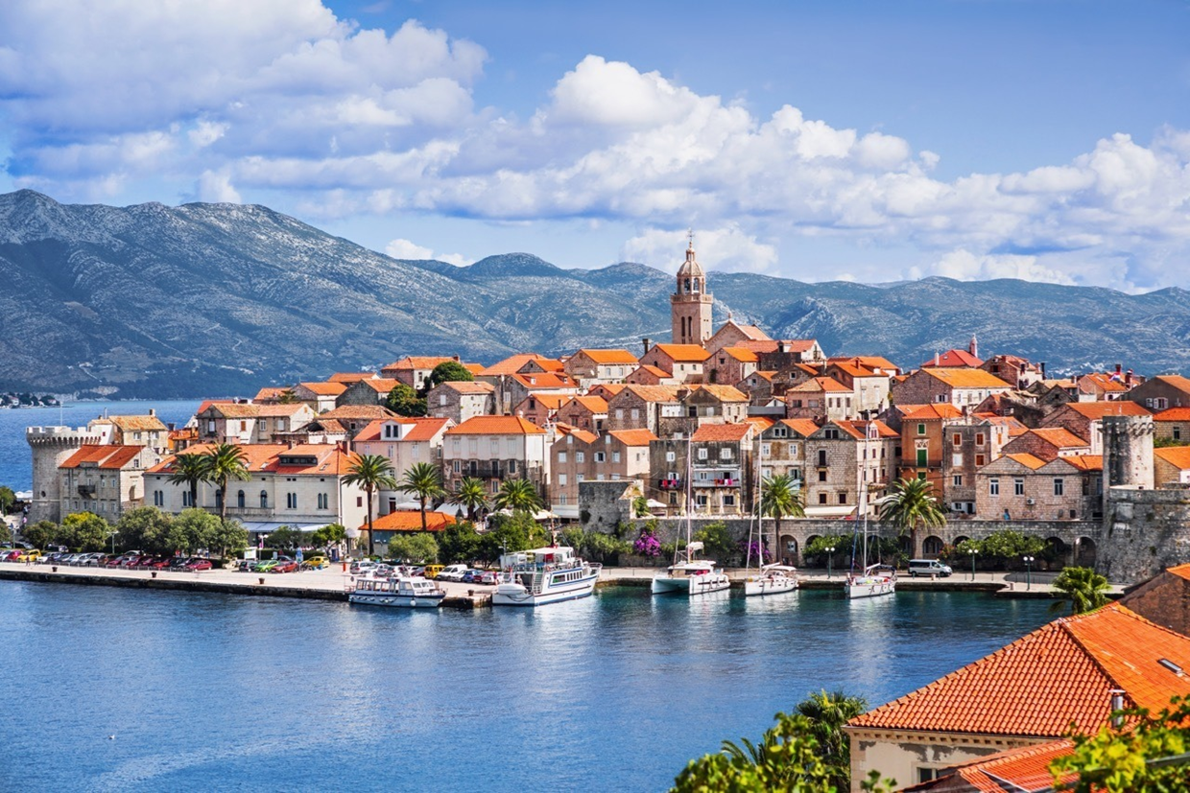

**CROATIA**

Your text here

**Today I learned about Croatia. Croatia used to be part of a country called Yugoslavia, but it became its own country only 25 years ago!**

**We learned about the island of Korčula and the island’s traditional sword dance called Moreška!** **I learned that the Croatian national animal is a marten and created my own marten!**

**FROM:**

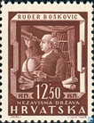Croatian Martens

**Today I learned about Croatia. Croatia used to be part of a country called Yugoslavia, but it became its own country only 25 years ago!**

**We learned about the island of Korčula and the island’s traditional sword dance called Moreška! I learned that the Croatian national animal is a marten and created my own marten!**

**FROM:**