Pre-Kindergarten Curriculum
Croatian Martens (Croatia)
5 minutes prep, 30 minutes of class time
This lesson is designed to introduce students to Croatia. Students will learn about the island of Korčula and the island’s traditional sword dance called Morseška. They will learn about the Croatian national animal, the marten. They will use markers and tissue paper to make their own marten.

Required Materials:
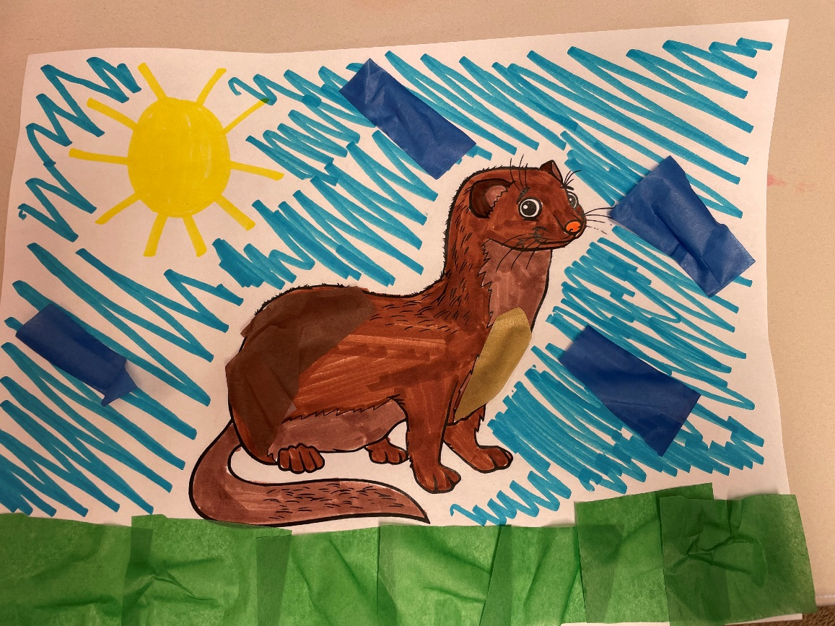
- Markers, colored pencils, or crayons
- Tissue paper
- Marten coloring sheet
- Glue or tape

Preparation: Print out as many needed marten coloring sheets. Place markers, crayons, or colored pencils and at each student’s table. Cut up blue, green, and brown tissue paper and place some at each student’s table. Give each student a marten coloring sheet.

Lesson Plan:
- Begin by asking the children what country we live in, and then help them locate that country on a map or globe. Then show them where Croatia is on a map/globe. (2 mins)
- Use the PowerPoint or printed images to take the children on a tour of Croatia. (see power point for more detailed notes on images) (5 mins)
  - First highlight the beaches, mountains, and historic Mediterranean towns of Croatia.
  - Second, discuss Croatian traditional clothes and food.
  - Next introduce the island of island of Korčula and the island’s traditional sword dance called Morseška.
  - Lastly, share the photo of the Croatian national animal, the marten.
- The activity (10 mins):
  - Explain to the students that the coloring sheet is of the Croatian national animal, the marten.
  - Show them that they can use the blue tissue paper to make the sky, the brown tissue paper on the marten, and the green paper to make the grass on the coloring sheet.
  - Tell them that they can also use markers, colored pencils, or crayons to color in the rest of the marten.

