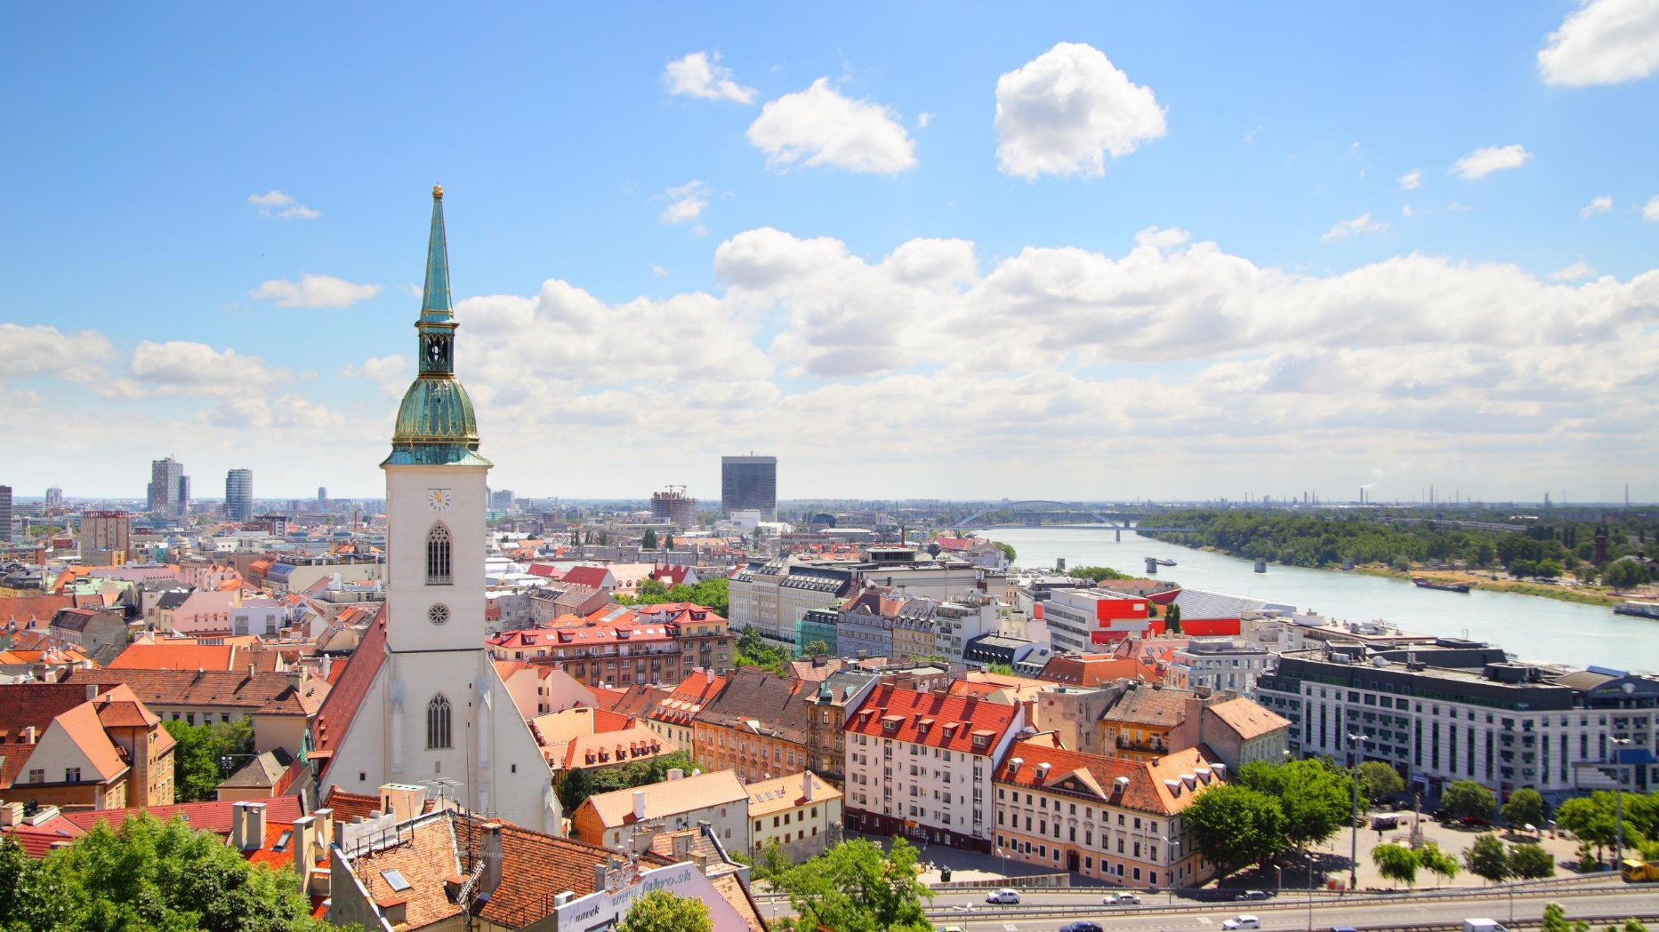

SLOVAKIA

SLOVAKIA

]

]

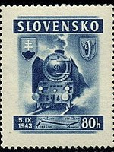**SLOVAK FOLKTALES**

**Today I learned about Slovakia and a Slovak folktale. The folktale is called Twelve Months, and it tells the story of a girl who is given violet flowers, strawberries, and apples in the middle of Winter. The folktale teaches that kindness and patience are important. I got to make my own violet flower today!**

**FROM:**

**SLOVAK FOLKTALES**

**Today I learned about Slovakia and a Slovak folktale. The folktale is called Twelve Months, and it tells the story of a girl who is given violet flowers, strawberries, and apples in the middle of Winter. The folktale teaches that kindness and patience are important. I got to make my own violet flower today!**

**FROM:**