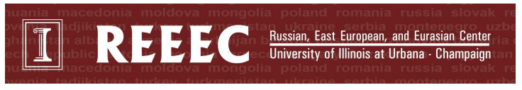
Culture Corner Curriculum (Orchard Downs)
Russia & Introduction to Tuva
This unit is designed to allow students 5 years and up to learn more about the country of Russia and the expanse of different cultures and regions found within the country. Participants will learn plenty about the world’s largest country, seeing photos of the Kremlin and Red Square in Moscow and the large expanses of nature found throughout Siberia. They will be introduced to the Tuvan Republic, found in the southernmost part of Siberia, and will learn about the tradition of throat singing and nomadic homes found there, called yurts. Students will then be able to color their own yurt or create one from a template. Younger children will be able to construct their own yurts using blocks.
- Show students photos of prominent Russian landmarks, the flag, the alphabet, etc. Introduce students to some common Russian greetings and words.
- Explain that Russia is the largest country in the world, and it covers a large amount of space. Show students photos of Siberia and the extreme weather experienced there.
- Show students the flag and alphabet of Tuva, a republic within Russia in the southernmost part of Siberia. Explain that in both Tuva and bordering Mongolia, there is a prominent form of vocal singing that is most popularly known as throat singing. Explain that Tuva is known for its incredible nature, and many nature examples can be found in their singing (for example, their voices mimic the sound of a river). Play students an example and ask them what they can hear in the singing.
- Explain that many people living in Tuva are known as nomads, meaning they have homes that are easy to move from one place to another. These homes are called yurts. Show images of yurt construction and explain that today they will get to either color or build their own yurts.
