Pre-Kindergarten Curriculum

Mexican Flores de Papel (Tissue Paper Flowers)
20 minutes prep, 30 minutes of class time
This unit is designed to introduce students to the country of Mexico. They will learn about the capital, Mexico City, step pyramids, Dia de los Muertos, and more interesting facts about Mexico. They will then learn how to make flowers out of tissue paper: a popular party decoration.

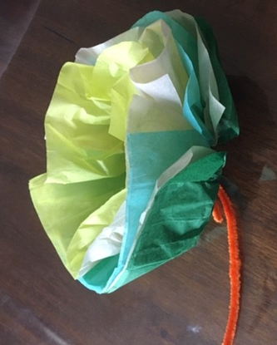
Required Materials:
- 10” x 10” sheets of tissue paper (five per student)
- Pipe cleaners

Preparation: Cut tissue paper into the shape of a square (the bigger the square, the bigger the flower). Place these squares at each student’s spot, along with pipe cleaners.

Lesson Plan:
- Begin by asking the children what country we live in, and then help them locate that country on a map or globe. Then show them where Mexico is on a map/globe. (2 mins)
- Introduce students to the country of Mexico with the images of Mexico City, The Mayan step-pyramid El Castillo, Dia de los Muertos decorations, school, family, and more.
- Students will then be introduced to the craft for the day: flores de papel (tissue paper flowers). These are a very popular party decoration throughout Mexico. Explain to the students the necessary steps to make the flowers:
  - First, if this hasn’t already been done, the tissue paper pieces must be cut into the shape of a square.
  - Fold the tissue paper back and forth, the same way you would to make a fan/accordion.
  - Wrap the pipe cleaner around the middle of the folded tissue, and twist it to be sure it stays in place. This is the stem of your flower!
  - Carefully separate each piece of tissue paper, spreading them out to resemble the petals of a flower. You’ve made your very own tissue paper flower!

