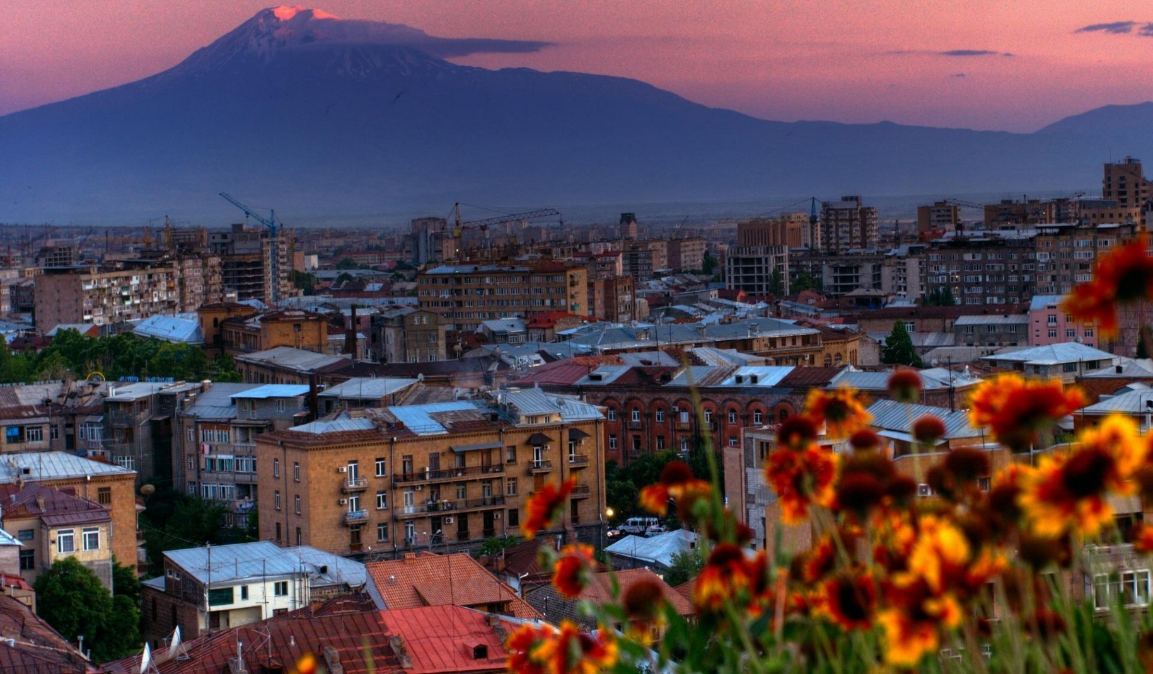

ARMENIA

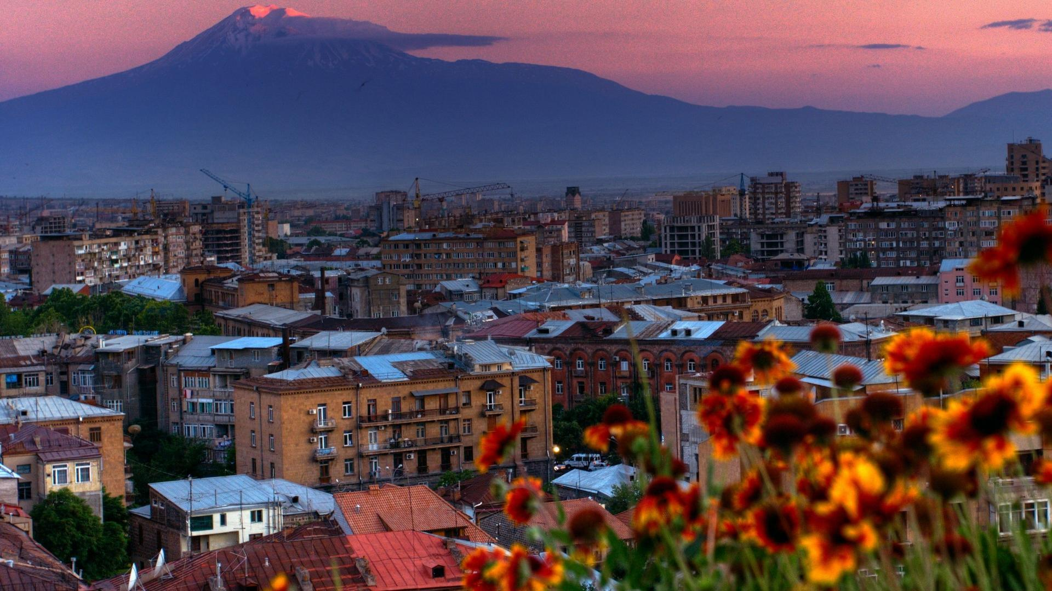

ARMENIA

  


**Pomegranates from Armenia**

Today, I learned about a country called Armenia. The pomegranate fruit is an important symbol of good luck & fortune to Armenians, and it is used in many traditional events.

I decorated my own Armenian pomegranate!

From:

From:

**Pomegranates from Armenia**

Today, I learned about a country called Armenia. The pomegranate fruit is an important symbol of good luck & fortune to Armenians, and it is used in many traditional events.

I decorated my own Armenian pomegranate!