Pre-Kindergarten Curriculum
Learning about Armenia & Pomegranates, the symbol of Armenia
20 minutes prep, 30 minutes of class time
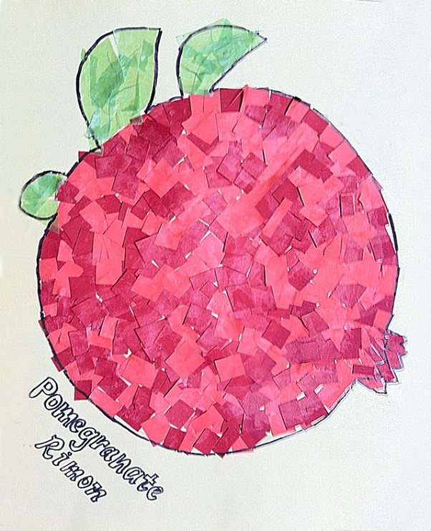
This unit is designed to allow students to learn more about the country of Armenia, a country in the Caucasus region. Students will be introduced to the country, the Armenian language, the famous Mount Ararat, and the capital city, Yerevan. The pomegranate fruit is often thought to be a symbol for the country of Armenia, symbolizing fertile lands and good fortune. It is also thought to guard Armenian people against ill will and evil. Students will learn about the pomegranate and how it is used in various traditional events and Armenian children’s stories. They will then be able to fill in their own printed image of a pomemgranate with red tissue paper squares.

Required Materials:
- Printed pomegranate coloring sheet
- Red tissue paper squares
- Glue stick/craft glue

Preparation: Place a printed pomegranate coloring sheet at each spot, along with glue sticks and a generous amount of red tissue paper squares.

Lesson Plan:
- Begin by asking the children what country we live in, and then help them locate that country on a map or globe. Then show them where the country of Armenia is on a map/globe. (2 mins)
- Use the printed images to introduce the class to Armenia, showing pictures of the capital city, Yerevan, and the famous Mount Ararat. (5 mins)
- Explain to students that the pomegranate fruit is a very important piece of Armenian identity, and that many people see the pomegranate as a symbol of the country. Show them a picture of the pomegranate, especially the inside of the fruit with its many seeds, explaining that Armenians say the fruit symbolizes fertile lands and good fortune. Pomegranates are traditionally used in weddings and even children’s stories usually end with a popular saying about pomegranates. (7-10 minutes)
- Explain the activity to the class (10 mins):
  - Each student will receive a printed sheet with the outline of a pomegranate, and they will fill in the shape using red tissue paper squares and glue sticks.
  - Once the pomegranates are dry, they are free to take them home!

